Electrical and Mechanical Load Design for Induction Motors
Hakan TERZİOĞLU^{1*}, Abdullah Cem AĞAÇAYAK²

Abstract – This paper is concerned with the modeling of motor loads in induction motors in response to the inability of general dynamic load models (GDLM) in their current form to capture the characteristics of induction motors. In order to fully analyze the response of induction motors to the inductive and mechanical loads to which they are subjected in industry, a simple mechanical load model is developed along with the inductive load. The aim of the study is to realize a cheaper mechanical load design by avoiding the high cost of inductive loads required to load the motor as the motor power increases. In addition, despite the GDLM, the proposed induction motor load models are developed to capture the dynamics represented by the proposed induction motor load models. The suitability of the proposed dynamic load model for analyzing the transient and steady state stability of induction motor loads is evaluated. With this load model, the importance of load analysis is demonstrated by revealing the rate of change of induction motor parameters with load.

Keywords – Equivalent Electric Circuit; Squirrel Cage Induction Motor; Induction Motor Modelling; Loading of Induction Motor

Introduction
According to a global energy assessment by the International Energy Agency (IEA), electric motor driven systems (EMDS) are responsible for 53% of the world's electricity consumption[1]. In the EMDS sector, 77% of electrical energy consumption is consumed by medium sized motors with power ratings below 375 kW. 80% of the medium-sized motors used are induction motors (IMs). The widespread use of IMs makes them an ideal candidate for energy efficiency improvements.
Among electric motors, squirrel-cage induction motors (SCIMs) are the most widely used motors in industry due to their simple and robust structure, low maintenance requirements, low failure rates, low cost and high efficiency. Asynchronous motors are widely preferred in industrial applications due to the fact that their speed changes very little under load and with direct mains voltage.
Nowadays, driving techniques, controllability, efficiency, behavior under all kinds of load and operating conditions are very important for induction motors widely used in industrial applications. In recent years, the voltage stability problem has been an important research topic. Voltage stability analysis requires accurate modeling of power system components, especially voltage regulators and loads. Studies have shown that the voltage dependence of loads is an important factor in voltage instability [1]. Most studies use nonlinear static models where active and reactive power are expressed as a function of voltage [2,3], while a limited number of studies use dynamic load models to investigate the dynamics associated with voltage stability [4]. Inaccurate modeling of loads has been a problem worldwide, causing blackouts [5]. Today, load modeling is usually performed using field measurements. This is still valid for slow dynamic loads. The goal is to make the load dynamics dominant by eliminating fast system transitions over a long period of time. The field measurements used include the full range of top-down load conditions, from heavy-duty industrial applications to residential loads. For such loads, first-order general dynamic load models (GDLM) are used to model their real power as well as their reactive power recovery characteristics [6,7]. However, this modeling approach assumes that the real power dynamics of the load are independent of the reactive power dynamics. Thus, it has been observed that the general dynamic load model is insufficient to explain the loads under different operating conditions of the induction motor [8,9].
This paper shows that the GDLM, which has been proposed in the literature to fully analyze the response of induction motors to inductive and mechanical loads that they are exposed to in industry, is insufficient to capture the characteristics of induction motors in their current form. For this purpose, a 4 and 5.5 kW motor was loaded with generators and inductive loads as well as with a mechanical load design of our own design. In this way, as the power of the motors increases, a simple load model has been created, avoiding the cost of the high power generators required to load them.

Materials and Method
In order to fully analyze the response of induction motors to the inductive and mechanical loads to which they are subjected in industry, an experimental setup and mechanical load design have been implemented. As motor power increases, the generators required to load the motor become more powerful, increasing cost. In addition, the load efficiency of generators varies according to their operating ranges. For example, if they are operated at less than the number of revolutions per minute that they should normally rotate, they have low efficiency and cannot load the motor sufficiently. We know that motors used in industrial applications also need to run at different speeds depending on the application. Therefore, their performance under load at high or low speeds must be accurately and completely analyzed. For these reasons, when loading an induction motor, we can overcome the disadvantage caused by the poor performance of the generator at low speeds by using the mechanical load as an auxiliary instead of using the generator alone.
The aim is that the designed load model can be used in any engine and is simple and inexpensive. The experimental setup of the engines is designed as shown in Figure 1.

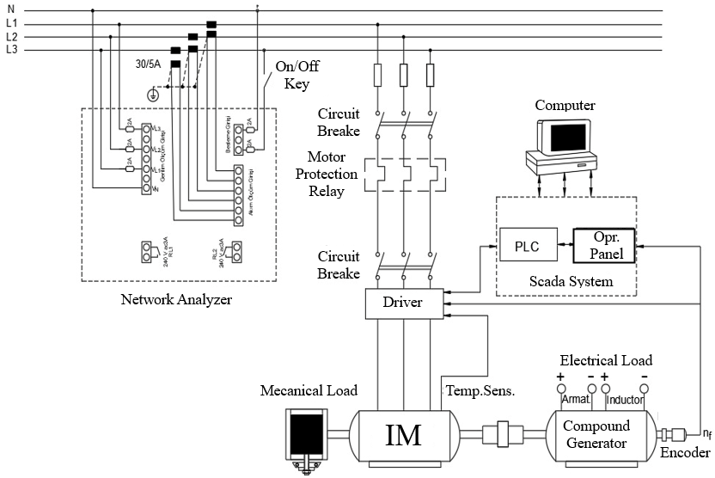
Figure 1. Experiment Connection Scheme.

By design, the induction motor is connected to the network via a continuous-time speed controller. It drives the motor with the data it receives from the motor (temperature, rotor speed) and the data it receives from the network (current, voltage, frequency, cosφ, etc.). In addition, the Siemens S7-1200 PLC uses this data to calculate other motor output parameters. Changes in these data can also be displayed immediately with a Siemens operator panel. With the computer, the measured and calculated parameters can be recorded throughout the experiment.
Elektrical Load
Compact generators are used as electrical load in the designed loads. The induction motors are electrically loaded by compact DC generators. Figure 2 shows the mechanical connection diagrams of the compact generators to the motors.
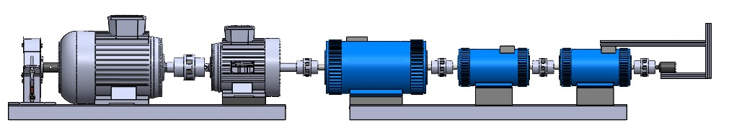
(a)

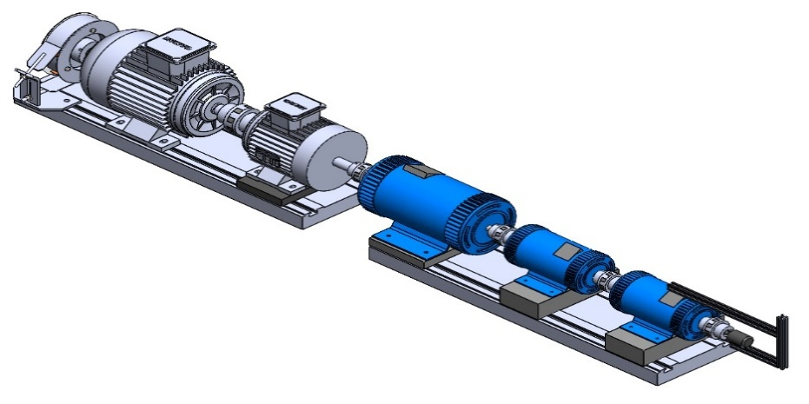
(b)

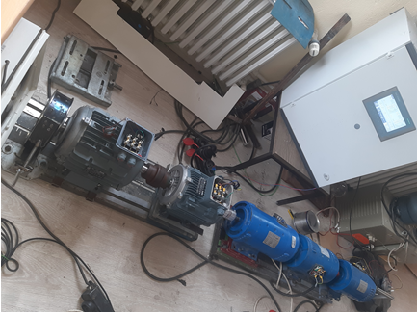
(c)
Figure 2. (a) Mechanical connection of an induction motor with a DC motor (b) Perspective view of the mechanical connection (c) Experimental connection application picture.

The electrical connection diagram for self-excited compact generators is shown in Figure 3. These generators are externally excited by a DC variac, and the energy generated by the generators as a result of the rotation of the motors must be spent on a load. This allows us to load the motor electrically.

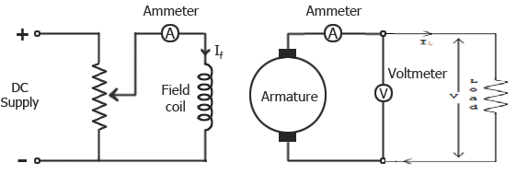
Figure 3 Electrical Connection of Generator, Variac and Load

The dynamo is loaded with a regulated DC variac and the motors are loaded at 100%, 75%, 50%, and 25% load ratios according to the current drawn by the motor. The motor and alternator nameplate data used in the study are shown in Table 1.

Table 1. Engine and compunt generator nameplate data
Values of Engines |  | 4kW | 5,5kW |  | Tag Values of Compunt Generator |  | 1,5kW | 2,2kW
Smb | Commentary | Value | Value |  | Smb | Commentary | Value | Value
V | Nominal Voltage | 400 V | 400 V |  | P | Power | 1,5 kW | 2,2 kW
I | Nominal Current | 8,2A | 10,8 |  | V | Nominal Voltage | 200 V | 200 V
φ | Power Factor | 0,81 | 0,84 |  | I | Nominal Current | 7,5 A | 15 A
rpm | Revolutions per minute | 1450 | 1455
2P | Number of dual poles | 4 | 4
Rs | Stator resistance | 5,67Ω | 8Ω
Terminal connection |  | Δ (Delta) | Δ (Delta)
Mechanical Load
Compound generators provide the highest efficiency in their operating speed ranges. At different speeds, it is difficult to provide the desired power and load to the motors. For this purpose, we have designed a mechanical load. The parts of the mechanical load are shown in Figure 4-a.

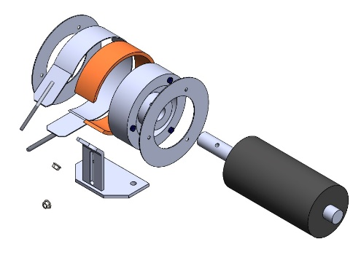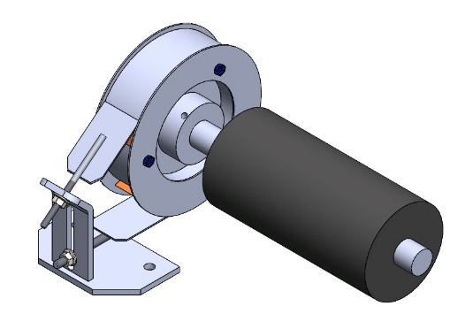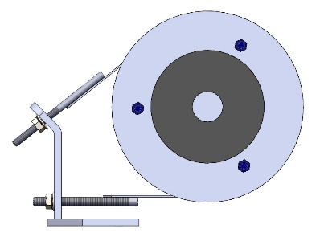
- (b) (c)
Figure 4. (a) Designed mechanical load components (b) Mechanical parts assembled and connected to the rotor (c) Connection of the mechanical brake disc to the pad tightening leg.
As shown in Figure 4-a, a cast disk with a diameter of 220 mm and a wall thickness of 60 mm was designed. The diameter of this disc was determined based on the motor size and the analysis result. The disk is surrounded by a lining riveted to a flexible 2mm sheet metal. In order to prevent this pad from loosening from the disk due to vibration during operation, 2mm circular plates were screwed on both sides of the disk. This prevents the pulley from slipping from side to side while the engine is running. In order to adjust the tightening ratio of the pad that wraps around the pulley, a 5mm thick metal foot was designed. This foot is fixed to the engine table and we are able to tighten the pad with the screws mounted on the end of the plate. Figure 4-c shows the connection of the disk to the pad tightening foot.
The amount of tightening can be adjusted with the screws on the connection foot. After the pad is tightened to a certain degree, the exact amount of load we want to apply to the motor can be precisely adjusted with the DC variac we apply to the AC generator. The actual mechanical load connection diagrams are shown in Figure 5.
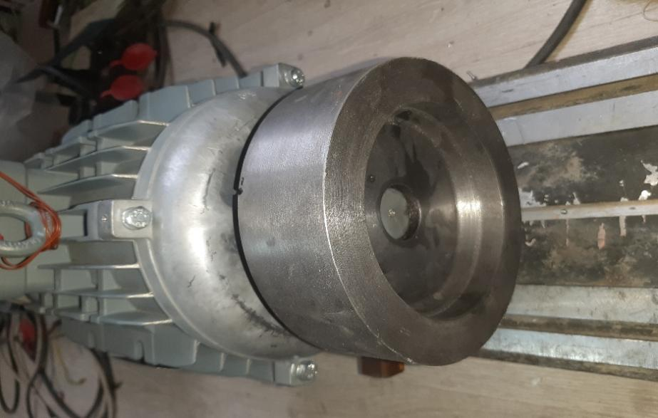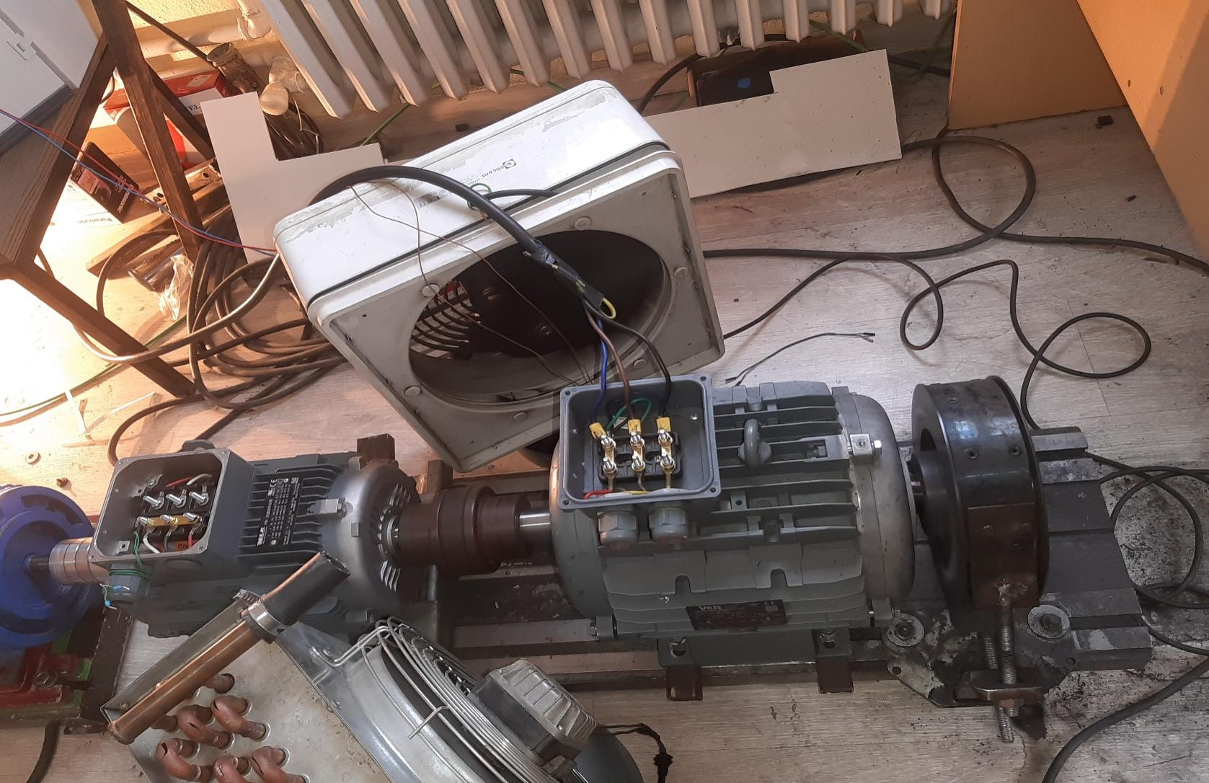

- (b)

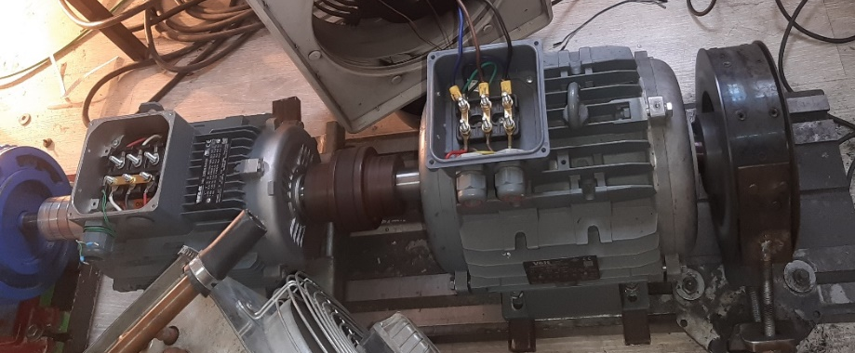
(c)
Figure 5. (a) Mechanical load disk connected to the induction motor shaft (b) Mechanical load creation with disk and lining (c) Mechanical connection of the motor to the experimental set.

Considering the size of the engine, the disc diameter was selected to be 220 mm and the width to be 60 mm. By selecting the disc as large as possible, it was planned to increase the friction surface, thus achieving more braking with less compression force.
The designed mechanical system was analyzed using the SOLIDWORK simulation program. This makes it possible to determine the effects of a mechanical change (stress and strain) on the system and the different wear zones to which the pad is exposed. The adequacy of the mechanical load on the system was demonstrated, with the intervention of possible errors in advance. In the simulation process, a structural analysis was performed and a homogeneous mesh distribution was made, taking into account the geometric difference on the structure. Temperature loads were included in the analysis and 298 Kelvin was set as the zero stress temperature. The mesh structure created with small parts to obtain reliable results in the analysis of the system is shown in Figure 6-a.
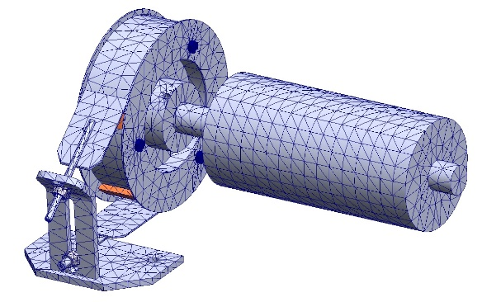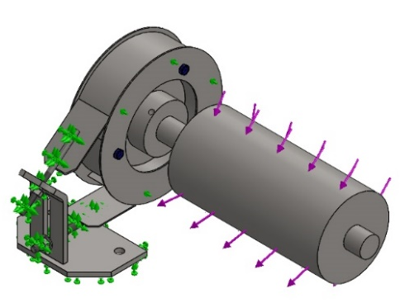
- (b)

Figure 6. (a) Mesh model (b) Load model.
As the material property of mechanical load, AISI1020 carbon steel was selected. The mechanical properties are yield strength: 3.51571e+08 N/m^2, tensile strength: 4.20507e+08 N/m^2, Young's modulus: 2e+11 N/m^2, Poisson's ratio: 0.29, coefficient of thermal expansion: 1.5e-05 /Kelvin. The loading model and the loading cases analyzed according to these properties are shown in Figure 6-b. As the maximum force to which the mechanical load will be subjected, we operated the 5.5 kW motor at 1500 rpm rotor speed under full load. Thus, we know that a design that can withstand this force can also withstand all other load rates and speeds. From the data obtained as a result of the experiment, it was found that 33 Nm of power was generated as an average of the torque. In the analysis program, the results of the analysis data given by the mechanical load were evaluated by passing through this torque ratio.
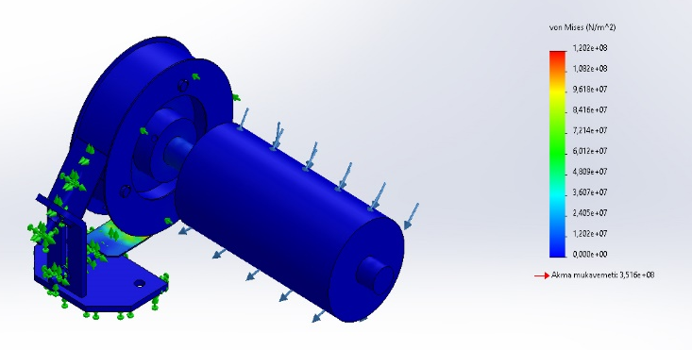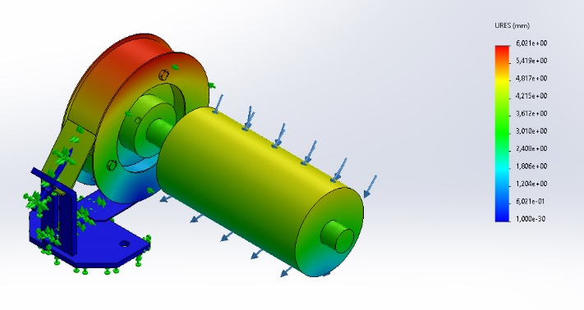
- (b)

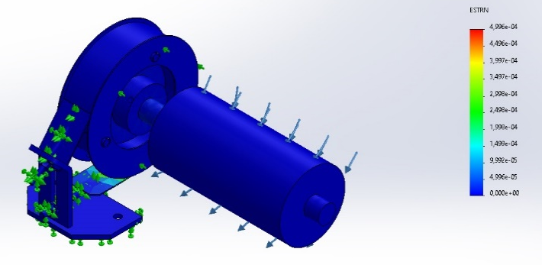
(c)

Figure 7. Mechanical stress analysis results (a) Stress (b) Displacement (c) Strain.

According to the analysis results, the maximum von Mises value of 1,202e+08N/m^2 was observed as a result of the tensile test of the mechanical load design in Figure 7-a. Considering the yield strength of the system of 3,516e+08N/m^2, it is 3 times of the structure, which shows us that the system is reliable. Figure 7-b shows the effective area and the ratio of force to mechanical load with color distribution and values. While the area exposed to the most force is shown in red, the area exposed to slightly less force is shown in yellow, and the area exposed to the least force is shown in blue. Figure 7-c shows the strain analysis of the design. While the equivalent strain shows maximum strength at 4,996 e-04, the designed load system is below 9,992 e-05 with a blue color code. This shows us how the average strain in the material changes depending on the amount of stress applied in one-way tensile or compression tests and is quite small. The structural analysis evaluation supports that the system is mechanically reliable.
Results and dıscussıons
This paper shows how we can solve the problems we face when loading induction motors with a low cost load model. It is seen that the load model GDLM proposed in the literature is insufficient to capture the induction motor characteristics in its current form. Therefore, GDLM needs to be improved to capture the dynamics of small induction motors (SIM load model). For this reason, a load model is emphasized to load both low power induction motors and high power induction motors.
In the experimental setup, a device was set up to load the induction motor both electrically and mechanically. The alternators used for electrical loading of induction motors are highly efficient and can provide full load at full speed. At lower speeds their loading capacity drops considerably. For this reason, especially as the motor power increases, it will not be able to load at low speeds, even if the same power is connected to the alternator. For example, while a 5.5kW alternator can load a 5.5kW engine to 100% at 1500rpm, it can only load a 375-750rpm engine to 50% at most. In addition, as these generators heat up, their load capacity decreases. Therefore, load efficiency cannot be maintained at the same level of power throughout an experiment. The widespread use of induction motors in industrial applications requires them to operate at any speed and under any load. This situation requires their operating characteristics at different speeds and loads to be fully analysed and driven in the light of these data. In order to overcome this problem, a mechanical load design has been realised in the experimental setup we have prepared to determine the motor parameters and behaviour. The mechanical load we have created is the deceleration of the engine shaft with a lining system. In this way, we were able to load the engine with the mechanical load at a certain rate, while at the same time we were able to realise the precise load adjustment with the alternators at low and high speeds without any problems. The designed mechanical load made it possible to load the alternator with the same power as the engine at low speeds as the engine power increased.
The mechanical load was analysed, designed and simulated based on the 33 Nm torque obtained with a 5.5kW motor at full load and speed. In all the analyses obtained from the simulation, the stress, displacement and strain ratios of the design were low or resistant. Their images and strength ratios are shown in Figure 7(a-b-c). In addition, the force in X-Y-Z directions to which the mechanical load is subjected in the analysis is calculated and shown in Table 1.
As a result, a load model has been developed to load motors with different loads at different speeds and loads. The developed load model is cost effective, easy to install and can be adapted to many motors. In particular, a practical and useful system has been designed to determine the effect of load on induction motor parameters and the response of induction motors under different load conditions in a laboratory environment. It is believed that this study will be a guide for future studies on the response of motors under load and at different speeds.

References
- Taylor CW. Concepts of undervoltage load shedding for voltage stability. IEEE Trans Power Del 1992;2(7):480–8.
- Berg GJ. Power system load representation. Proc IEE 1973;120: 344–8.
- Ohyama T, et al. Voltage dependence of composite loads in power systems. IEEE Trans Power Appar Syst 1985;PAS-104:3064–73.
- Sekine T, Ohtsuki H. Cascaded voltage collapse. IEEE Trans Power Syst 1990;1(5):250–6.
- Taylor CW. Power system voltage stability. New York: McGraw- Hill, 1994.
- Hill DJ. Nonlinear dynamic load models with recovery for voltage stability studies. IEEE Trans Power Syst 1993;1(8):166–76.
- Xu W, Mansour Y. Voltage stability analysis using generic dynamic load models. IEEE Trans Power Syst 1994;1(9):479–93.
- Borghetti A, Caldon R, Mari A, Nucci CA. On dynamic load models for voltage stability studies. IEEE Trans Power Syst 1997;1(12):293– 303.
- Prasad GD, AI-Mulhim MA. Performance evaluation of dynamic load models for voltage stability analysis. Int J Electr Power Energy Syst 1997;8(19):533–40.
- Balanathan R, Pahalawaththa NC, Annakkage UD. Undervoltage load shedding for induction motor dominant loads considering P, Q coupling. IEE Proc Gener Transm Distrib 1999;146(4):337–42.
- Kundur P. Power system stability and control. New York: McGraw- Hill, 1994.
- Stanley HC. An analysis of the induction motor. AIEE Trans 1938;57:751–5.
- Işık, F. 2000. Taguchi Metodu ve Bir Uygulama, Yüksek Lisans Tezi, İstanbul Üniversitesi Sosyal Bilimler Enstitüsü, İstanbul. 75.
- Taylan, D. (2009 ). Taguchi Deney Tasarımı Uygulaması, Yüksek Lisans Tezi, Süleyman Demirel Üniversitesi Fen Bilimleri Enstitüsü, Isparta. 73.
- Taguchi, G., Chowdury, S., Wu, Y., 2005. Taguchi’s quality engineering hanbook. ASI consulting group, LLC, Livonia, Michigan, ISBN 0-471-41334-8.
- Şirvancı, M., 1997. Kalite için deney tasarımı. Literatür yayınları. İstanbul, 110s.
- E. B. Agamloh, A. Cavagnino, and S. Vaschetto, “Accurate determination of induction machine torque and current versus speed characteristics”, IEEE Transactions on Industry Applications, vol. 53, no. 4, pp. 3285–3294, 2017. DOI: 10.1109/TIA.2017.2675984.
P. C. Krause and C. H. Thomas, “Simulation of symmetrical induction machinery”, IEEE Transactions on Power Apparatus and Systems, vol. 84, no. 11, pp. 1038–1053, 1965. DOI: 10.1109/TPAS.1965.4766135.

